Assignment 2 - ShoppingVue

Name: Jie Bao

Student No.: 20082475

1.Description of Web app.

This vue app is for shopping. It is deployed to firebase.
In homepage, it shows what is the function about my vue app.
In Goods page, it connects the heroku and shows the data in the mlab which connected to heroku. In this page, we can also achieve to incease the amount of goods, change goods details and detele the good. We can click the edit and it will open the update goods page, we can change the detail of the good we selected.
In AddGood page, we can select which kind of good and type in the amount, price and id to add the good to goods page.
In login page, we can sign in with google, facelbook and email. Only after sign in, we can click goods page and customers page.
In Customers page, we can find the customers details and upvotes. If we don't login, it will ask us to login.
In Map page, we can mark the location and add goods but Google Map quota only have 1 time per day.
In Video page, we can search the video from youtube and watch the AD of the web and goods. Of course, it can search my video and watch it.

2.E2E Testing.

Before I implement the login function, I have finished the cypress test. But after I implement the login function, I found that cypress can't test the login function. It says that google refused the connection. And in my web, I have to login and can manage goods and customers. I attach the URL of the Travis build page for the Vue app I have done the login function before:
https://www.travis-ci.org/JieBao666/ShoppingVue.

3.Automated Deployment.

https://shoppingvue.firebaseapp.com

4.Use case diagram
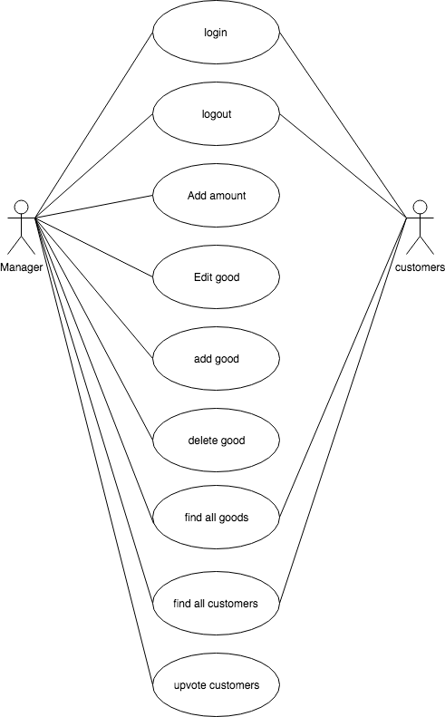

5.Github repository.

https://github.com/JieBao666/ShoppingVue-2.0

6. UX/DX approach adopted.

E2E test
Git
Material Design Guidelines
7.Reference

https://github.com/mjurkowski/vue-simple-auth
https://github.com/akulubala/vue-youtube-player
8.Youtube Link

https://www.youtube.com/watch?v=D2XbASycrrY&feature=youtu.be

